**Authoring a challenge wheel game**

Current as of May 31, 2017

Background

A module can display a special box that will launch a challenge wheel game.

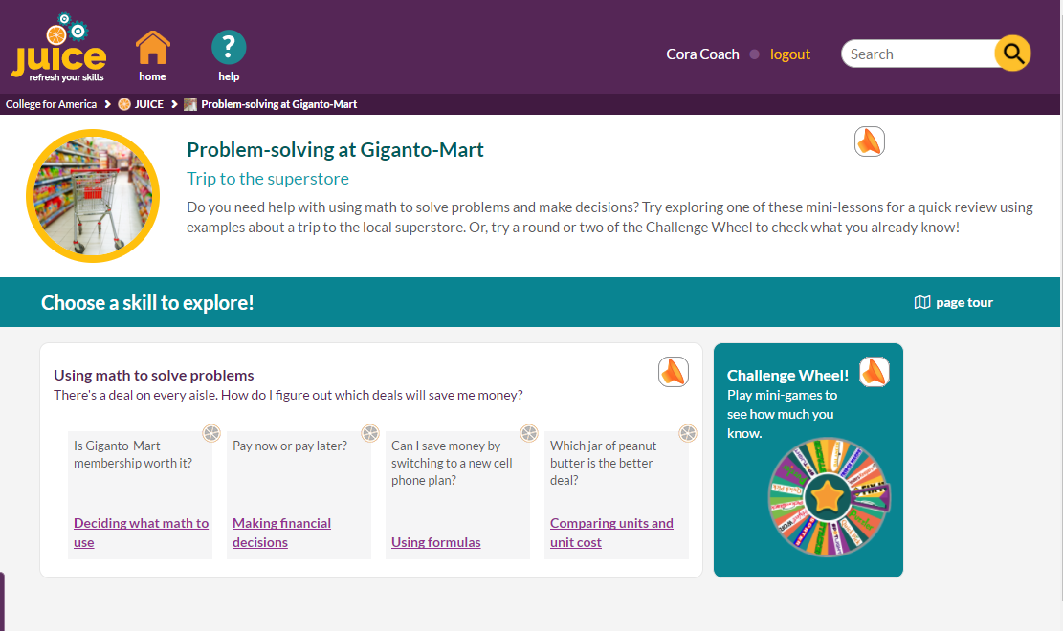

Challenge wheel games typically have 1 round for each mini-lesson in the module; each round exercises the skill covered in its related mini-lesson. Challenge wheel games display a special view of the scoreboard that lists each round’s skill and contains a link that allows students to go directly to the mini-lesson that covers that skill.

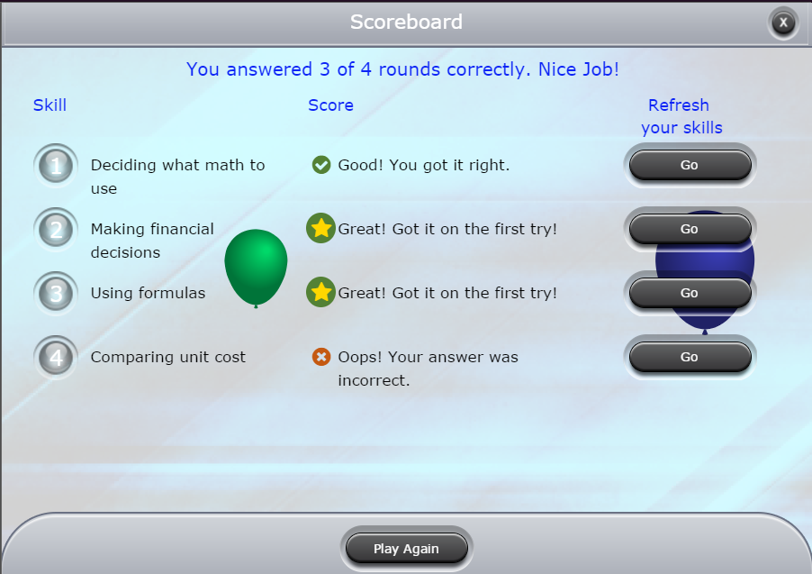

The scoreboard information is added to the challenge wheel game during the authoring process using a special version of the authoring template that displays only if the game file is called “challenge_wheel.”

As of May 31, the site will automatically use any file called “challenge_wheel” that is located in a module’s directory for the challenge wheel game for that module, as long as the module has its “challenge_wheel_available” setting set to “yes.” The site will play the file using the widget that is specified in the module.

Not all games have been updated to show the special version of the challenge wheel authoring template. As of now, these games definitely do support it:

Quick Pick Spotlight Fridge magnets

Balancer Finders Keepers Pick and Stack

Puzzler does not.

Authoring a challenge wheel game and adding it to the site

1. Start by adding a new track to tab 3 of the modulette called “Challengewheel.” Make sure the track number you add is not already in use.
2. Add the correct widget instance for the game you are authoring to the track.
3. Add a new file to the widget instance. IMPORTANT! The filename must follow this EXACT convention:

[module id].challenge_wheel

Example: chris3_D4.challenge_wheel

This will cause a file named “challenge_wheel” to be created in the module’s directory in S3.

It will also cause each game template to display an additional section at the top of each round. This is hidden for “regular” games.

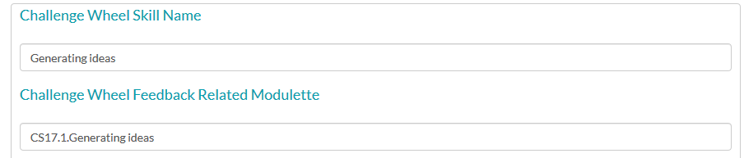

4. Author the game. For each round:

1. Add the mini-lesson title that is associated with the round to the Skill Name field. This text will display to the user on the scoreboard.
2. Add the **mini-lesson id** and name or title to the Related Modulette field. This will be the modulette that the Scoreboard “Go” button links to. You can use either the name or the title--the site will launch the correct mini-lesson based on either one.

See the example above.

5. To QA your challenge wheel game, preview it from CAMPER.

6. When you are ready to make the challenge wheel game available in its module, update the module as follows:

* Check the challenge_wheel_available checkbox.
* Choose the widget for the challenge wheel in the Challenge Wheel Widget Type dropdown:   
    
  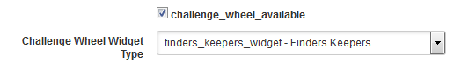

7. Publish the module to dev. This will allow you to play the challenge wheel game on the dev server.

8. When you are ready to push your challenge wheel game to production, use the tools in the files table to copy the file first to QA and then prod. Then use the tools in the modules table to publish the module to QA and then to prod.

You do not need to publish the Challenge Wheel modulette.